|  |  |  |  |  |  |
| --- | --- | --- | --- | --- | --- |
| Date | 12-Dec-22 | | | Tester Name | Andrew McLaughlin |
| Environment | Penfax - Test | | | Login used |  |
| Operating System | Windows | Version: | Update: | | |
| Software Used | Edge | Version: | Update: | | |
| Select Software | Version: | Update: | | |
| Release version | 22.4.1 | | | | |
| Title | E5.33 Terminate someone over the age of 55 and end reason death_ spouse | | | | |
| Test Type | Regression | | | | |
| Test Scenario | E5.33 Terminate someone over the age of 55 and end reason death_ spouse | | | | |
|  |  | | | | |
| Expected Results | Employment should be ended with the End Reason Death.  Member Status should be Deferred and then Deferred Survivor.  Pre-Retirement Death with Spouse Option Letter should be available on DC Benefit Calculation and Communication in Penfax. It should also be available in Member PLANet (PENWEB). | | | | |
| Pass/Fail | Pass | | | JIRA# | N/A |

Describe your steps with screenshots:

1. Bring up active SK member who is over the age 55 and is married. 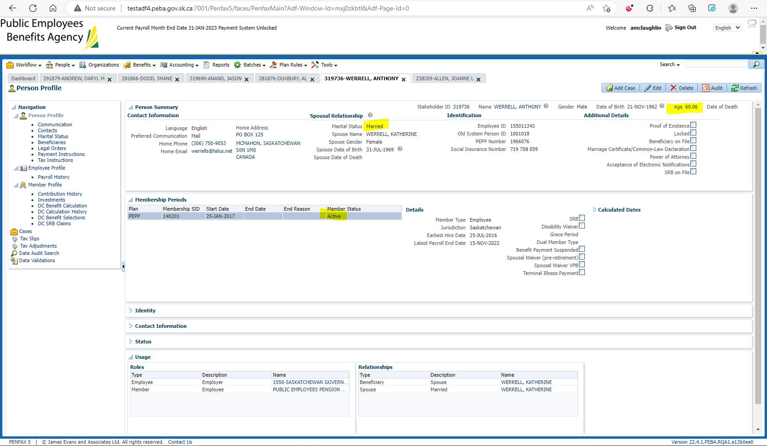
2. Log into DCT. Select an Employer from the dropdown and click on Import Data. Upload a CSV file for Termination. Validate, approve and process the file.
3. Go to Penfax and then Data Posting Batches. Click on Data Posting Batch ID, go to Pending tab and validate and then submit the transaction records. 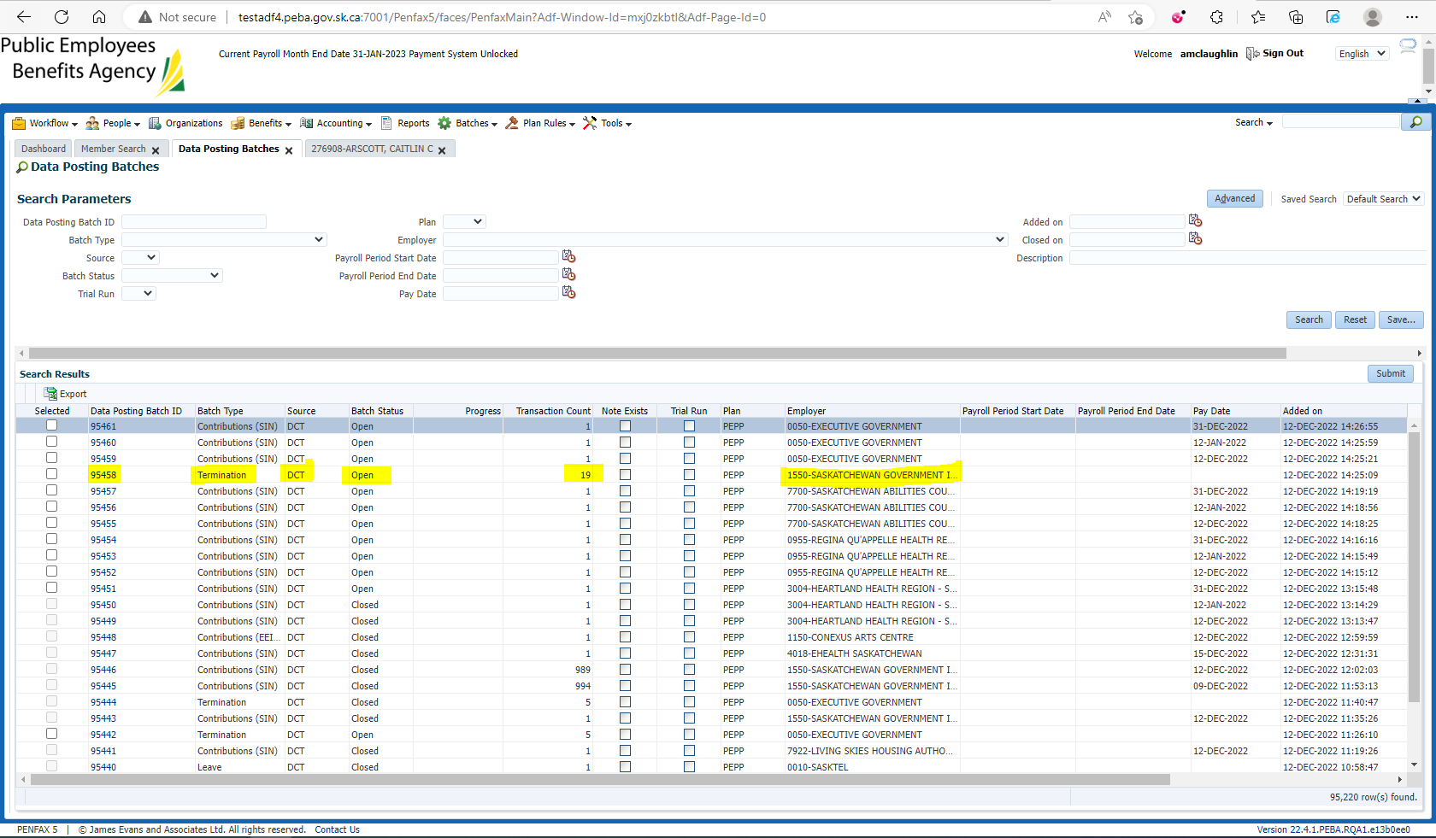
4. Once the data posting batch is submitted, bring up your member.
5. Go to Employee Profile -> Employment Periods, employment should now have the End Date and the Termination as the End Reason. 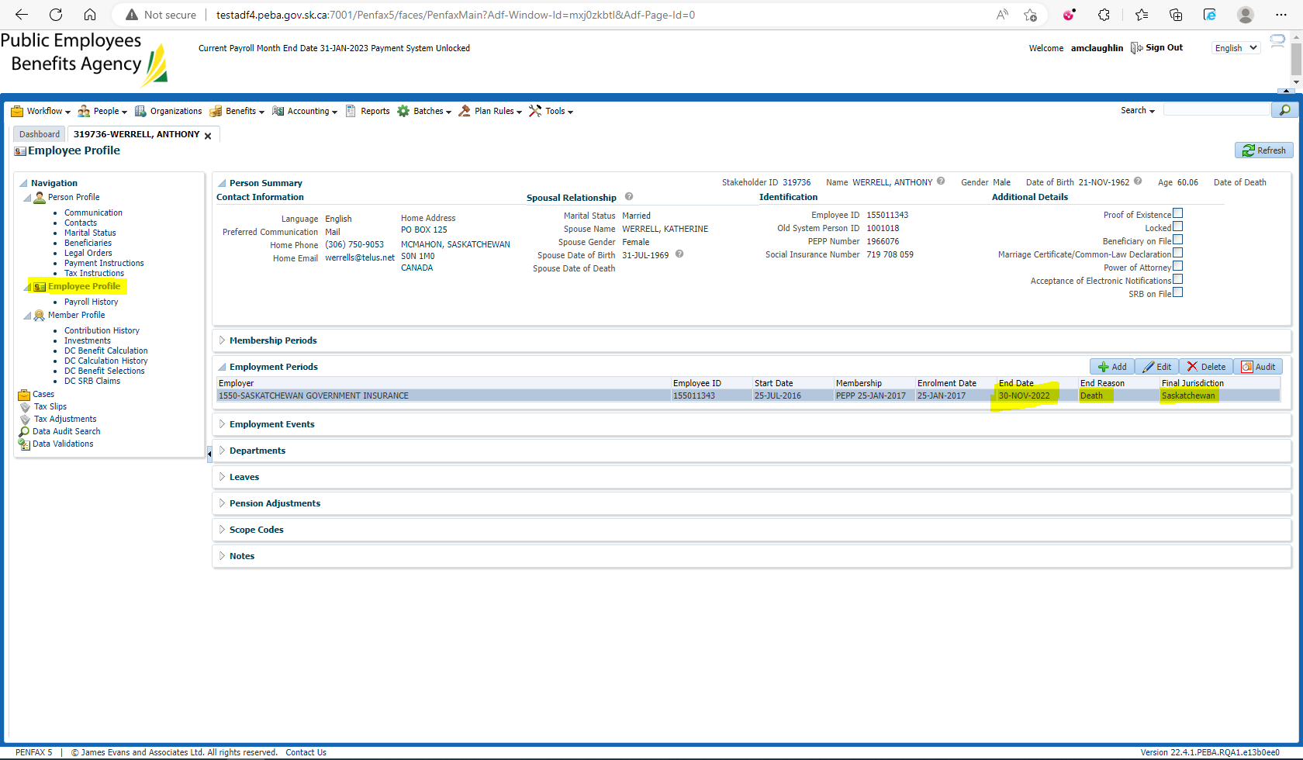
6. Go to Member Profile. Member Status should now be the Deferred. 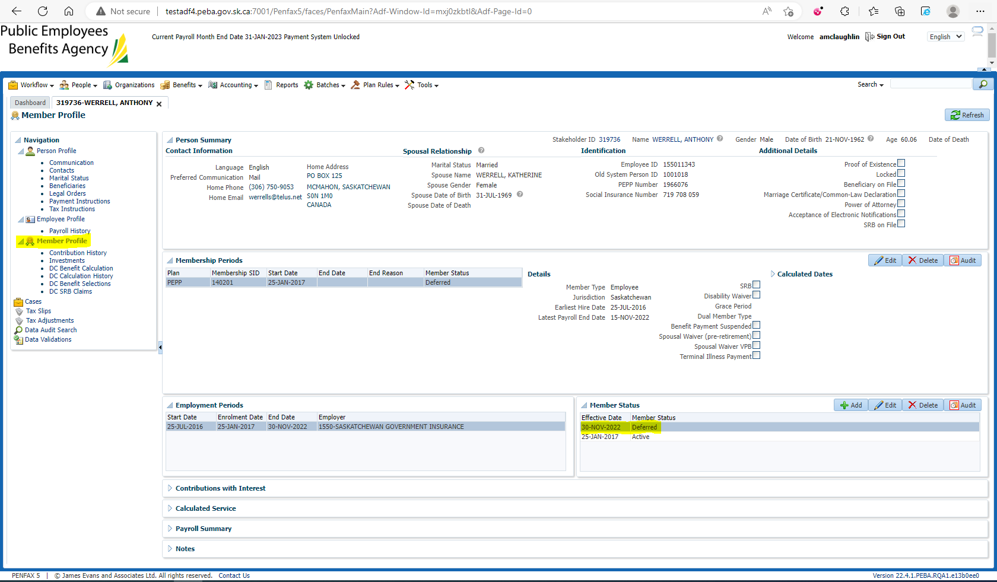
7. Enter death date under person profile.

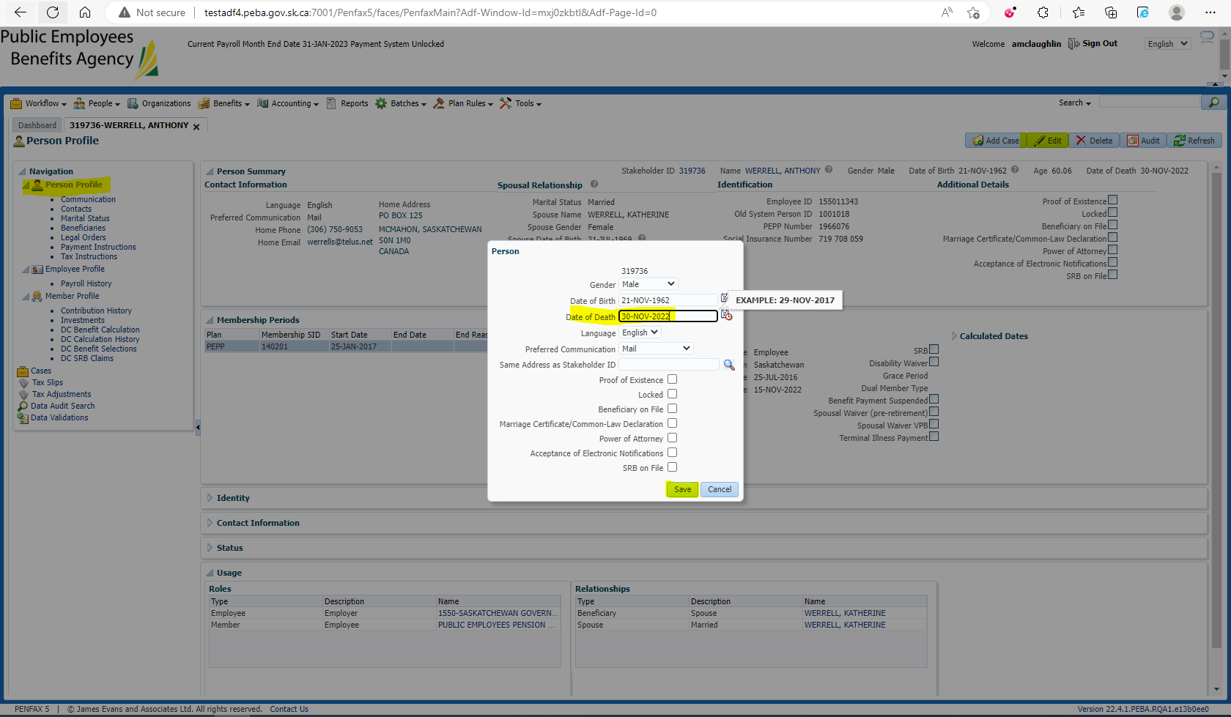

1. Under Member Profile, Member Status should be now Deferred Surivor.

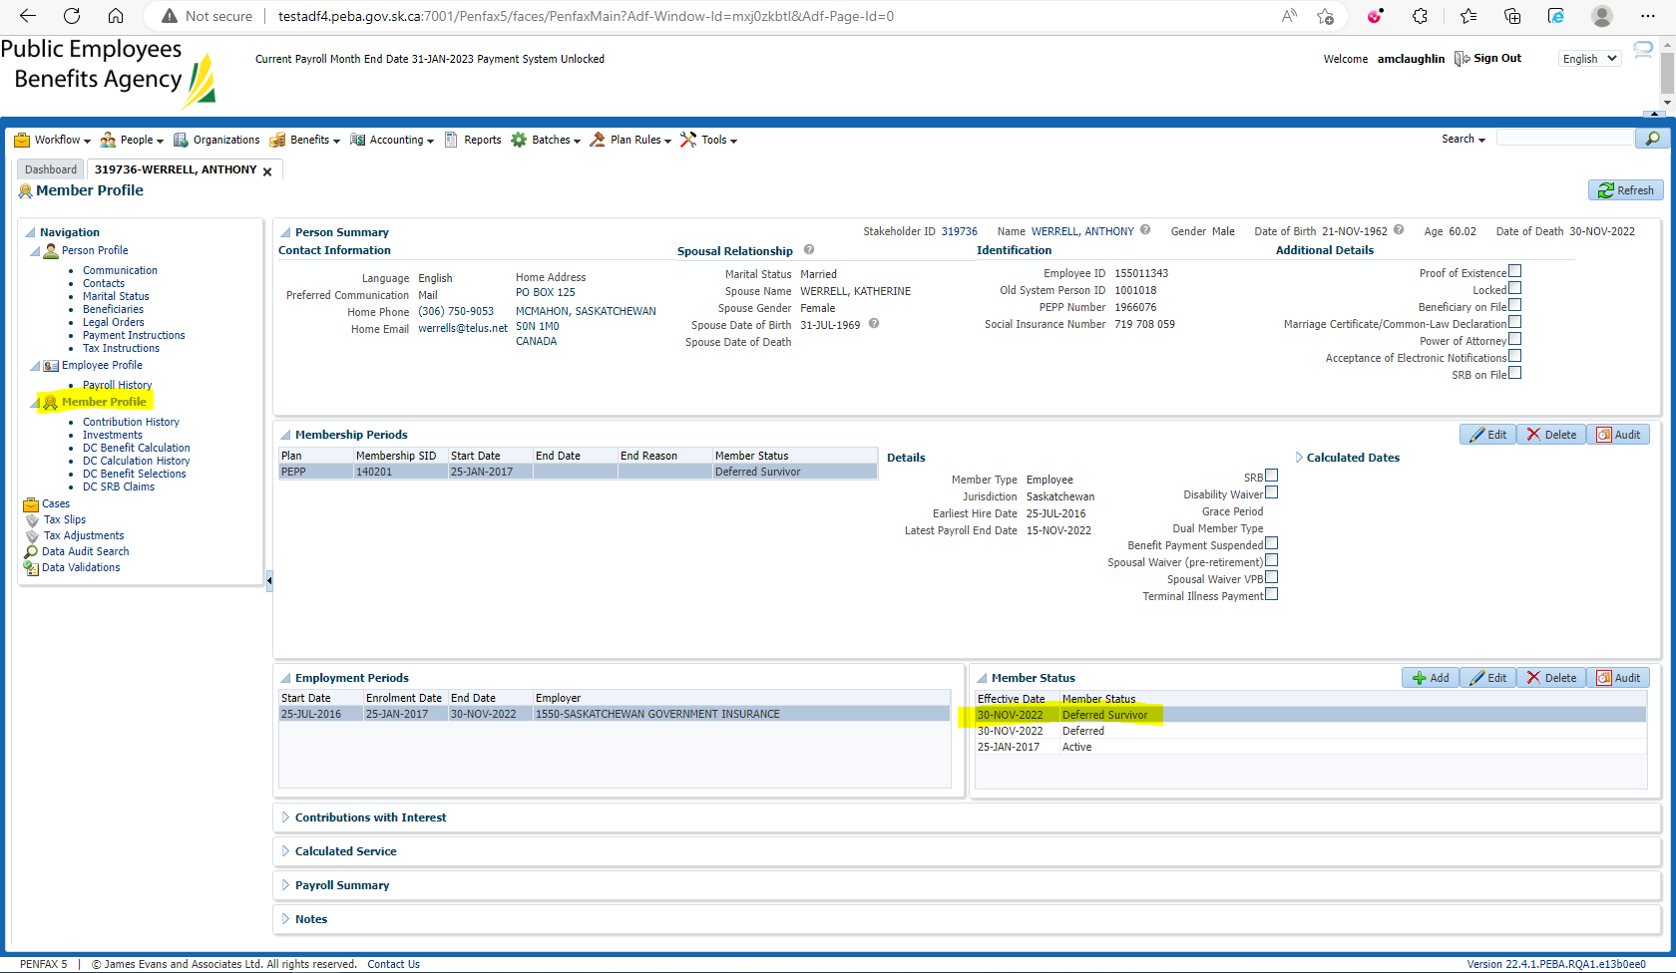

1. Run the DC calculation with death date pre-populated and jurisdiction pre-populated based on final jurisdiction under employee profile. 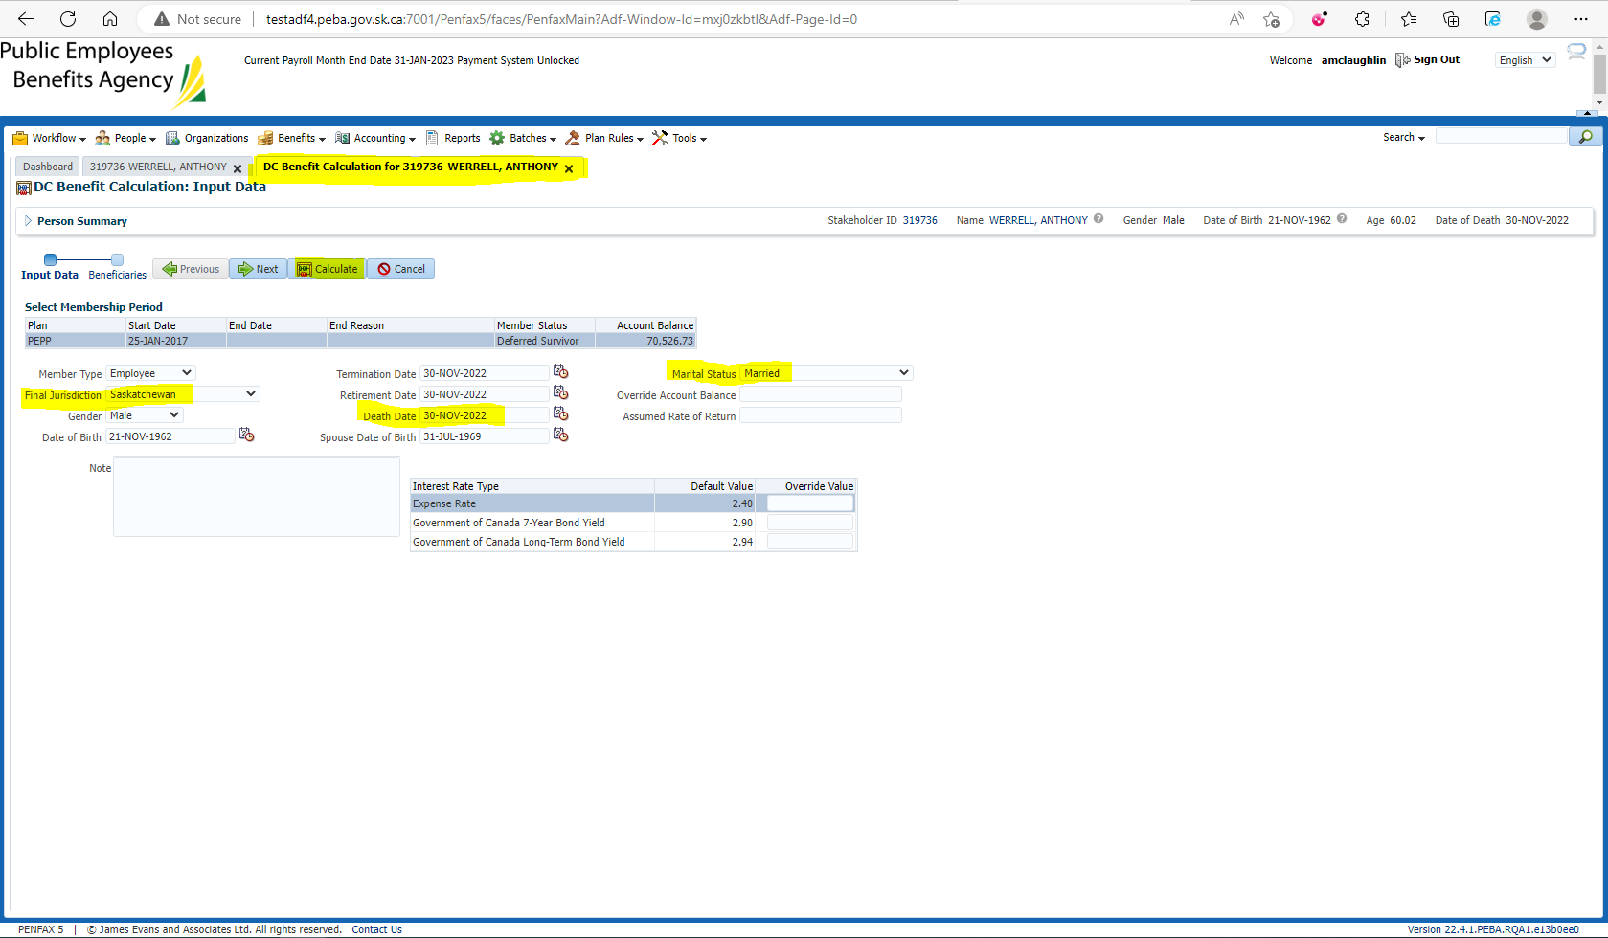

Click Next

Click Calculate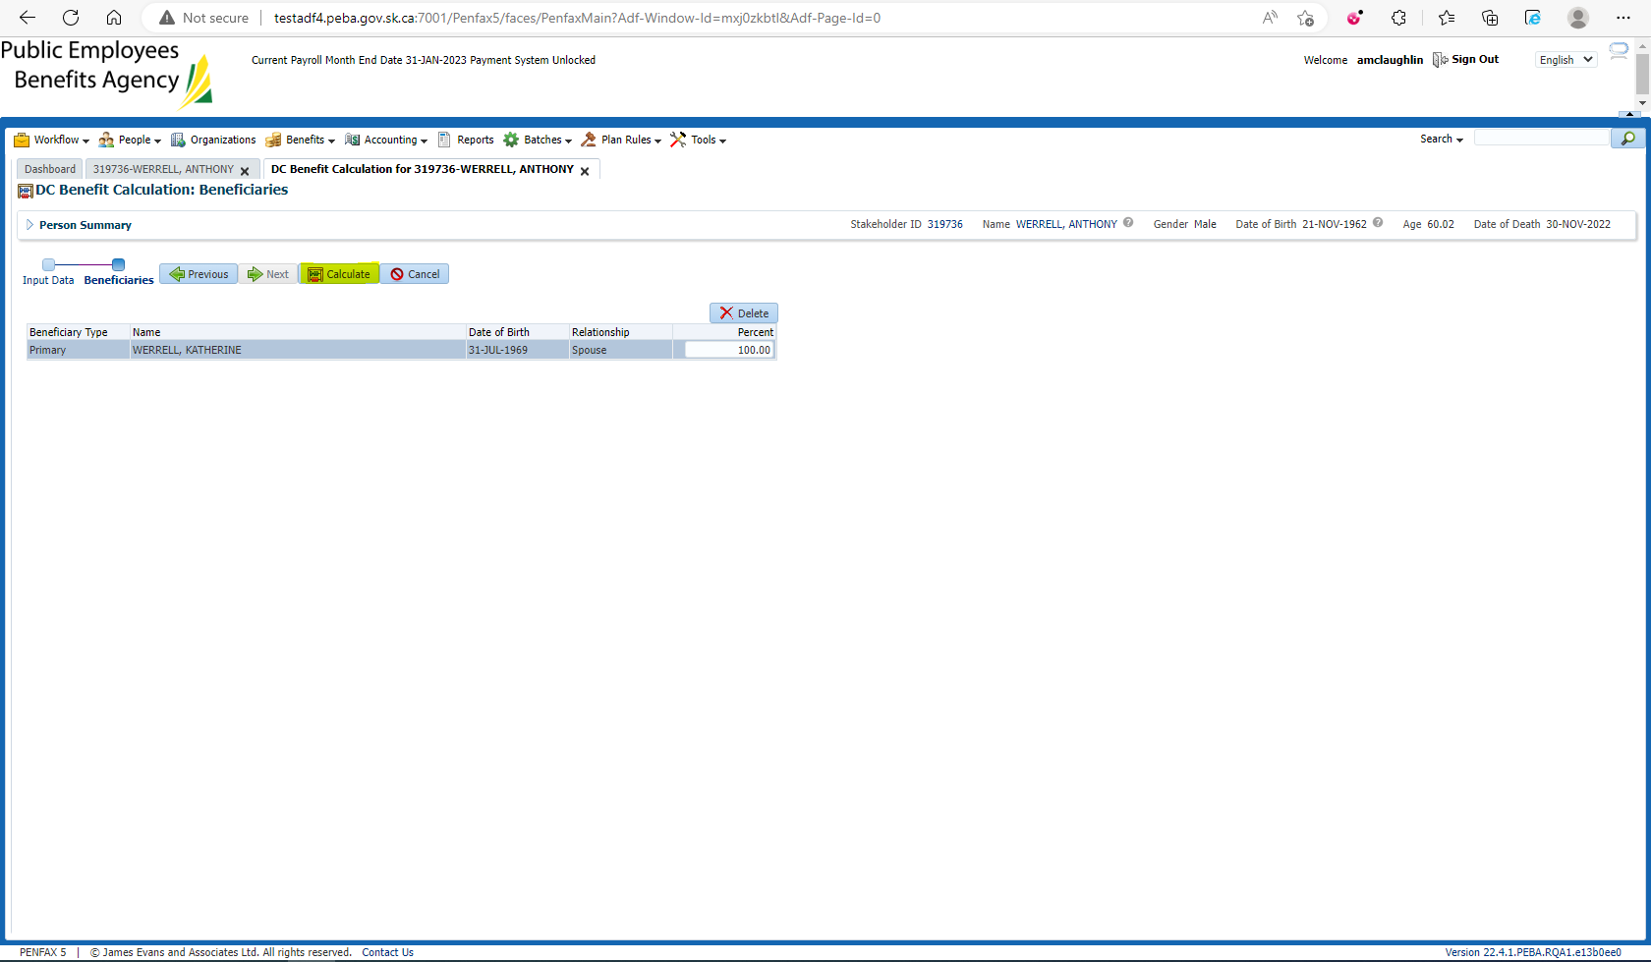

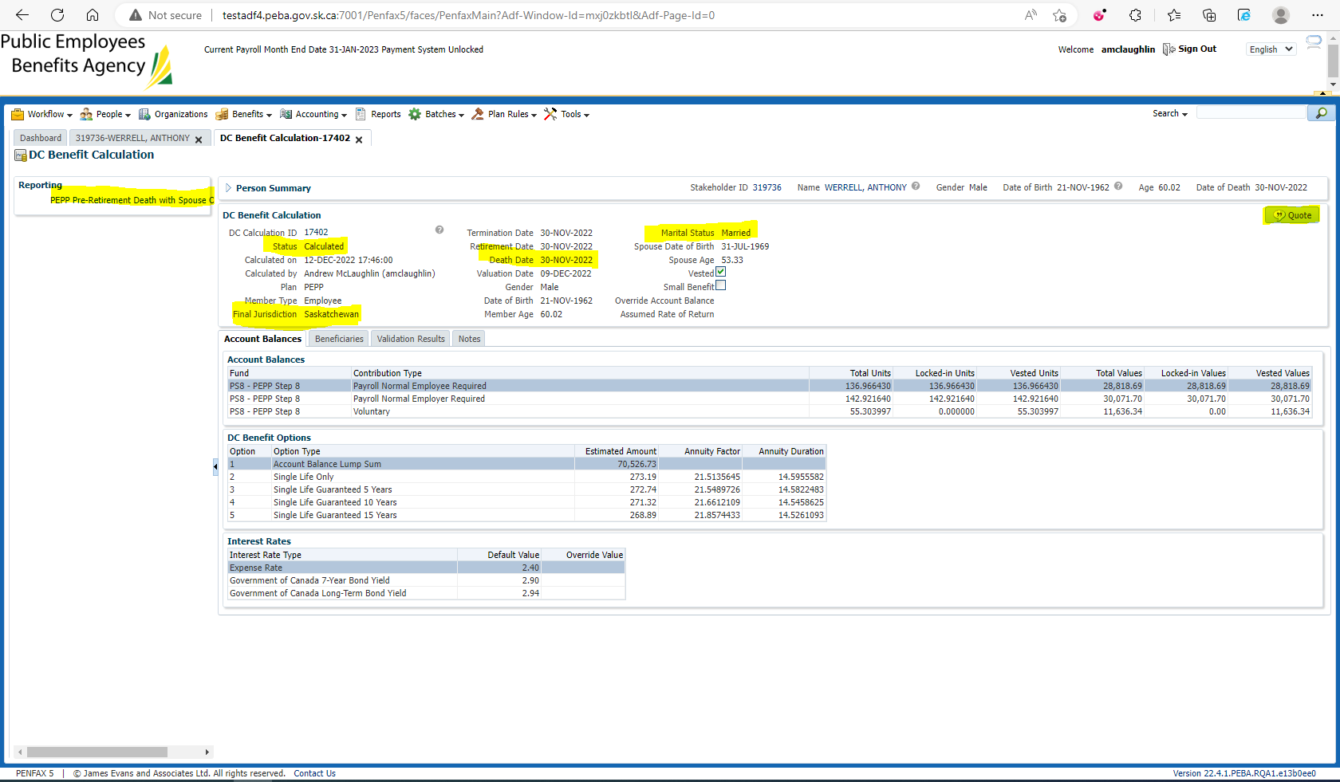

1. Click on Quote
2. Pre-Retirement Death with Spouse option letter should be available on the same page.
3. Click on Communication. Under Outbound documents there should now be the same letter saved and generated called PEPP_PREDTHWSP_OPTION Letter.

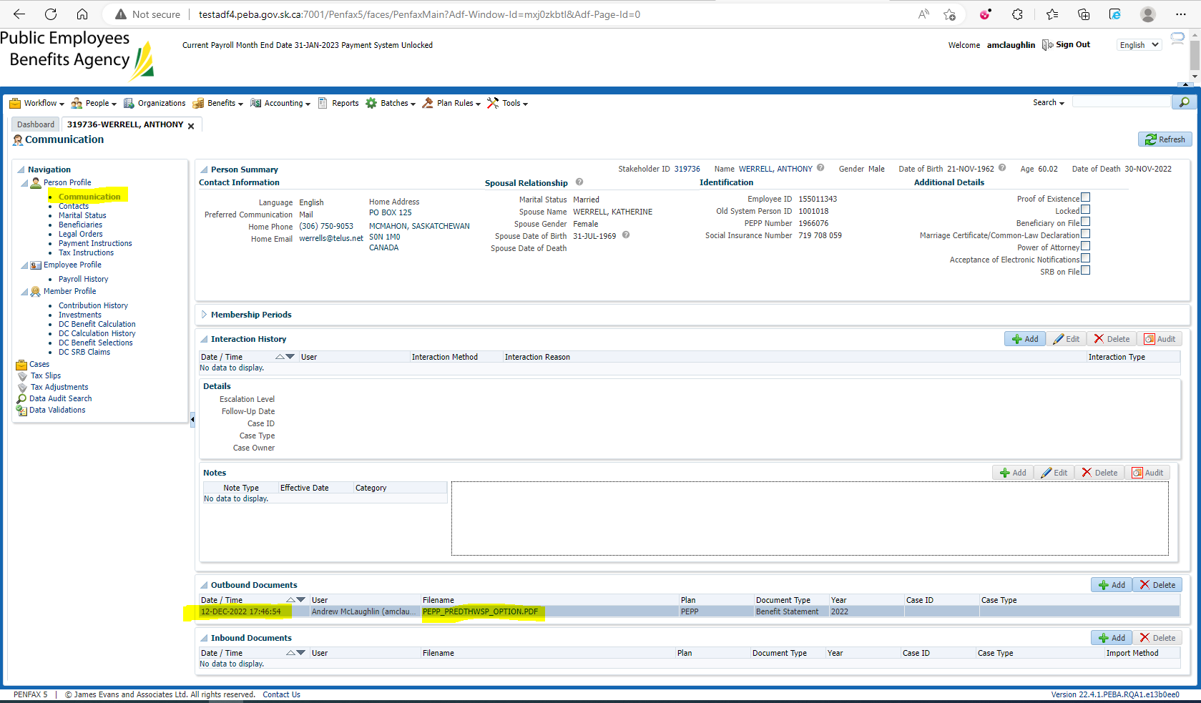

1. PDF Letter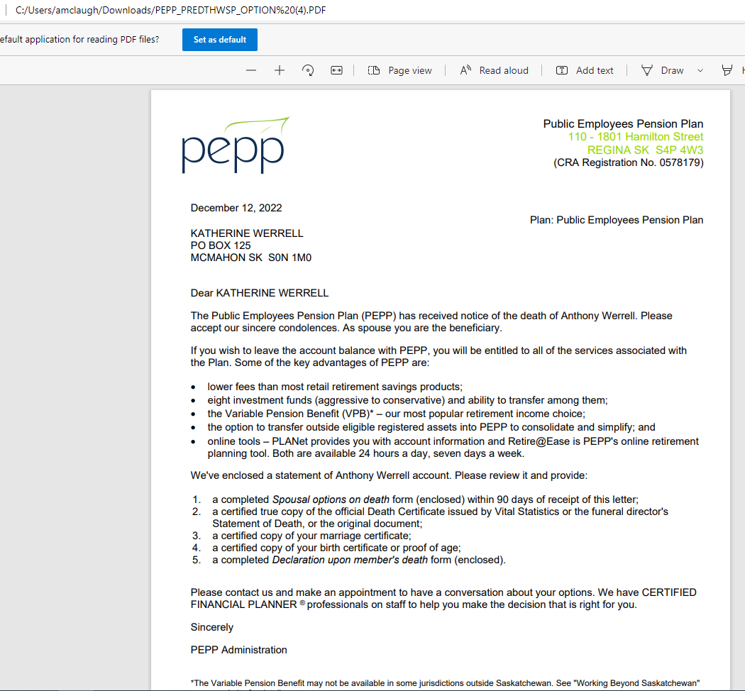
2. Death Option Letter should be available on Member PLANet. 